# PROJECT DOCUMENTATION:

**PROJECT TITLE:-**

**COMPETITIVE ANALYSIS OF LEADING TRAVEL AGREGATORS TEAM:-**

Team ID : LTVIP2023TMID08026

Team Size : 4

Team Leader : Lavanya Santhoshini Damalanka Team member : Kotapadu Sravani

Team member : Kotana Sharmila Team member : Ommi Sumithra

**1. INTRODUCTION:-**

**Overview:-** A competitive analysis of leading travel aggregators is a comprehensive report that evaluates the strengths, weaknesses, opportunities, and threats of key players in the online travel aggregation space. This report aims to provide valuable

insights for businesses, investors, and industry stakeholders to make informed decisions and stay competitive in the dynamic travel industry.

**Data Collection and Preprocessing:-**A comprehensive dataset was collected from KAGGLE which includes age, sex, region, charges, smoker, BMl. The collected data underwent thorough preprocessing to handle missing values, remove inconsistencies, and ensure data quality.

**Exploratory Data Analysis (EDA):-**EDA was conducted to gain a deep understanding of the dataset. Visualizations and summary statistics helped in understandingthe characteristics of the data and guided further analysis.

**Creating a Flask web application:-**For Competitive Analysis Of Leading Travel Aggregators data involves building an interface where We can input relevant information, and the application will use the predictive model to estimate the medical care costs.

**Purpose:-**The purpose of conducting a Competitive Analysis of Leading Travel Aggregators is to gain valuable insights into the competitive landscape of the online travel aggregation industry. This analysis provides a comprehensive evaluation of the strengths, weaknesses, opportunities, and threats of key players in the market.

Analyzing user reviews and satisfaction ratings of different aggregators can provide valuable customer insights. This helps businesses understand customer preferences, pain points, and expectations, enabling them to improve their services.

Overall, the Competitive Analysis of Leading Travel Aggregators is a crucial tool for businesses, investors, and industry stakeholders to gain a deep understanding of the competitive dynamics in the online travel aggregation space and make informed decisions to stay competitive and thrive in the market.

# KEY OUTCOMES:

1. Convenience and Efficiency
2. Price Comparison and Savings
3. Increased Access to Travel Options
4. Enhanced Patient Care
5. Tailored Insurance Coverage

# LITERATURE SURVEY:-

* + Literature may assess the impact of travel aggregators on various stakeholders in the travel industry, including airlines, hotels, tour operators, and traditional travel agencies. This includes examining the effects on distribution channels, pricing dynamics, and market competition.So The literature survey on travel aggregators typically covers the following aspects:
  + Business Models and Industry Analysis: Studies may focus on the business models adopted by travel aggregators, including revenue streams, pricing strategies, and partnerships. They may also analyze the overall industry structure, market trends, and challenges faced by aggregators.
  + User Behavior and Experience: Research in this area examines how travelers interact with travel aggregator platforms, their booking patterns, search behavior, and user experiences. It may also explore factors influencing user loyalty and satisfaction.
  + Impact on Travel Industry: Literature may assess the impact of travel aggregators on various stakeholders in the travel industry, including airlines, hotels, tour operators, and traditional travel agencies. This includes examining the effects on distribution channels, pricing dynamics, and market competition.
  + Remember that the specific literature available will vary based on the publication date and the focus of individual researchers. Conducting a comprehensive literature review will provide you with the most current and diverse insights into the world of travel aggregators

# THEORITICAL ANALYSIS:-

Creating a detailed block diagram for Competitive Analysis of Leading Travel Aggregators involves breaking down the process into key steps and components. Below is a high-level block diagram outlining the main stages and elements involved in estimating andpredicting Analysis of travel Aggregators.

**BLOCK DIAGRAM:-** The block diagram illustrates the end-to-end process of estimating and predicting Analysis oftravel Aggregators.

## Data collection

* + - Literature survey
    - Social or Business impact



**Web Integration**

Visualizations with info

**Problem understanding**

**Competitive analysis of leading travel aggregators**

* + - Business requirements

Downloaded dataset from KAGGLE

## Data preparation

**Data visualization**

**DashBoard**

**Story**

Logged into IBM Congnos analytics and created data module

Created several unique visualizations

Created airline

dashboards

Guided journey slide show

## Report

Dashboard, Report, Story was Deployed into UI with flask

# SOFTWARE OR HARDWARE DESIGNING:-

## Software Requirements:-

1. IBM cognos analytics Tool.
2. Flask.
3. Integrated Development Environment (IDE)-Spyder.

This software will allow travel agents to eliminate the paper information brochures that they receive from tour companies by downloading electronic versions of these brochures directly from the computers of the tour companies .This will reduce paper cost and will also increase the accessibility of information that is stored at a distant locations.

## Hardware Requirements:-

* + Minimum System Requirements (RAM-4GB, Quad core Processor or above)
  + Hardware requirements are system should have 2 GB Ram, 80 GB hard disk Space. Find below added images to know more details about Abstract and SRS of the system.
  + Hardware system requirements often specify the operating system version, processor type, memory size, available disk space and additional peripherals, if any, needed.

# 6. RESULT:-

**DATA VISUALIZATIONS**:-

**no_of_passengers by device_type_used:**

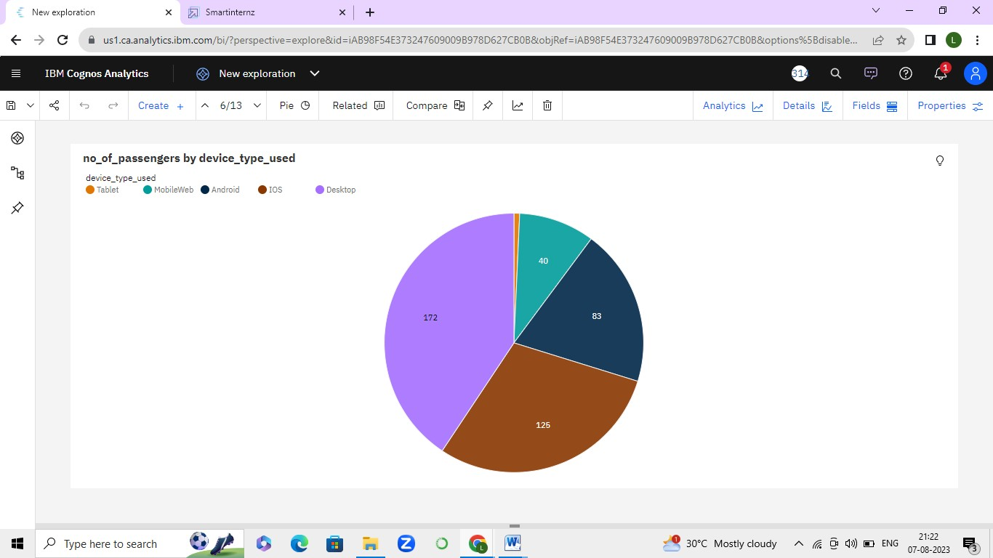

no_of_passengers by Year colored by to_city:

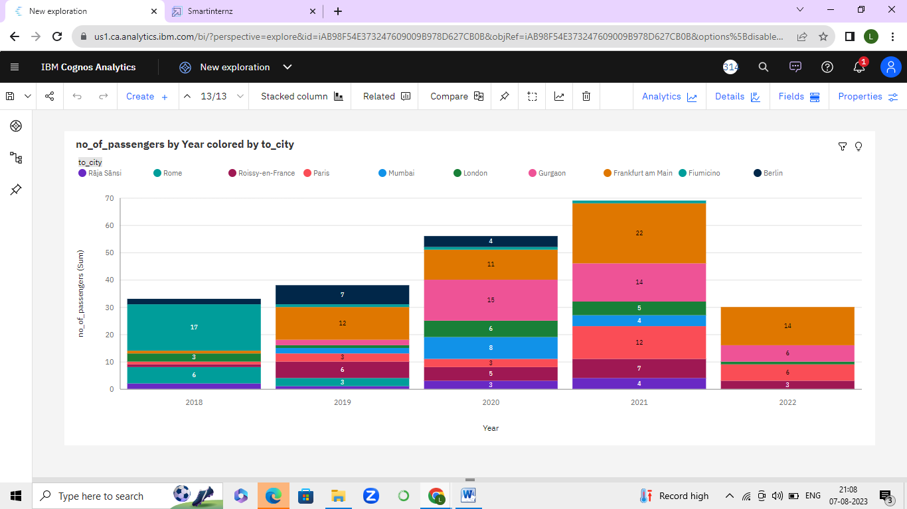

no_of_passengers by Year:

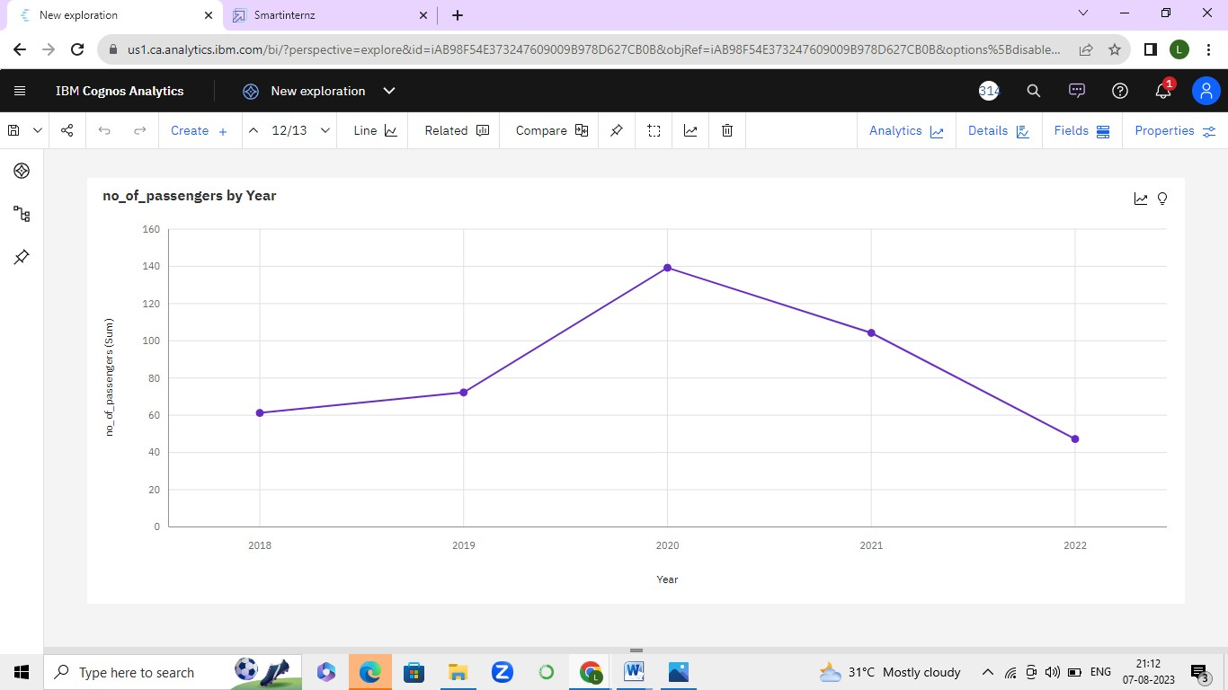

INR_Amount by Day colored by from_city:

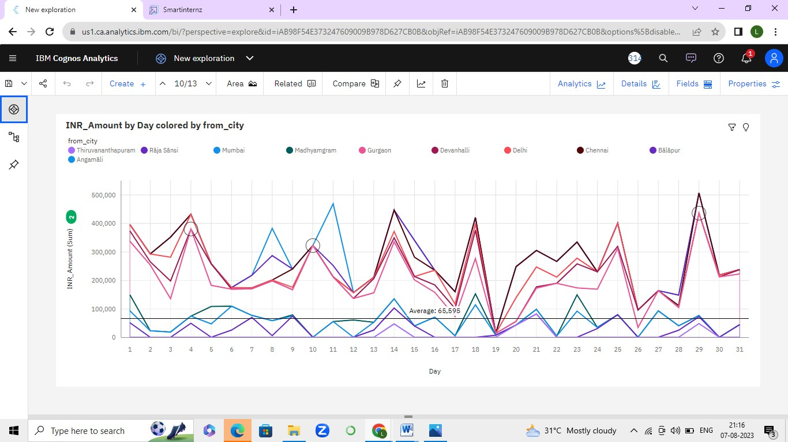

no_of_passengers by Day colored by Day:

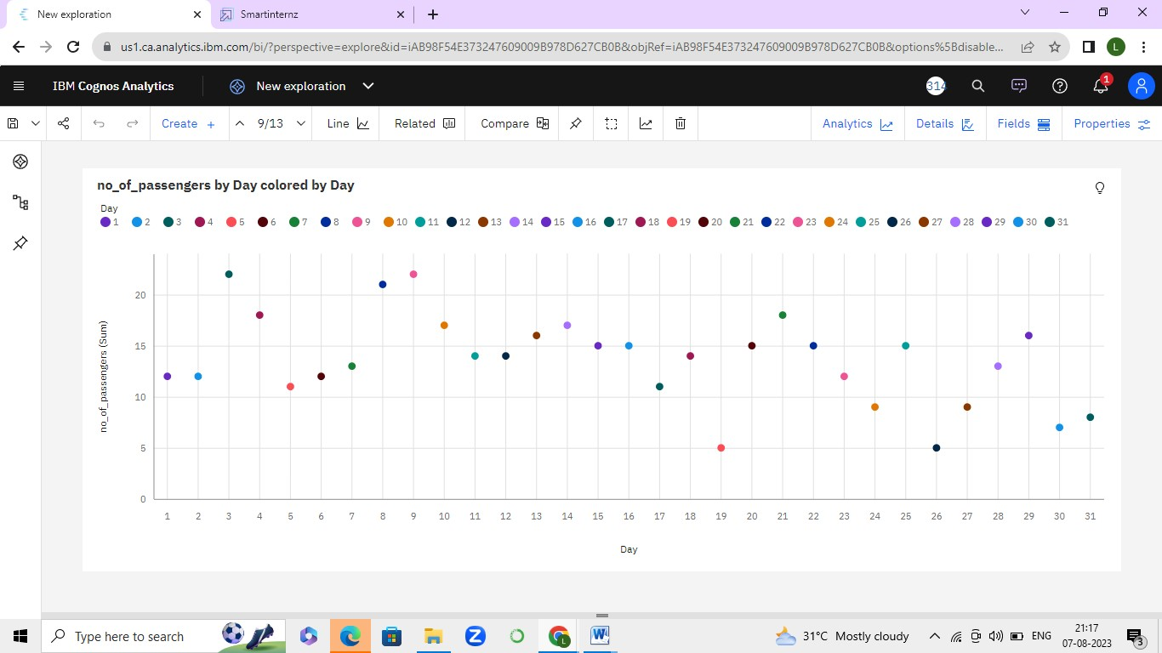

Comparing 2 visualizations:

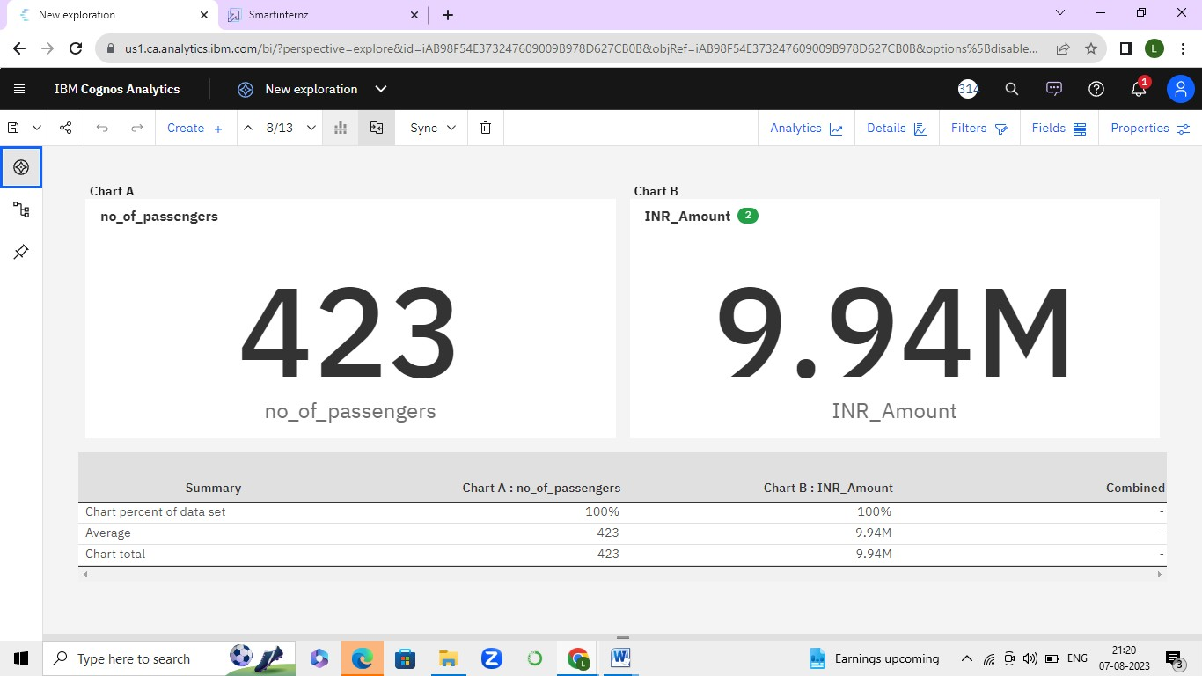

no_of_passengers:

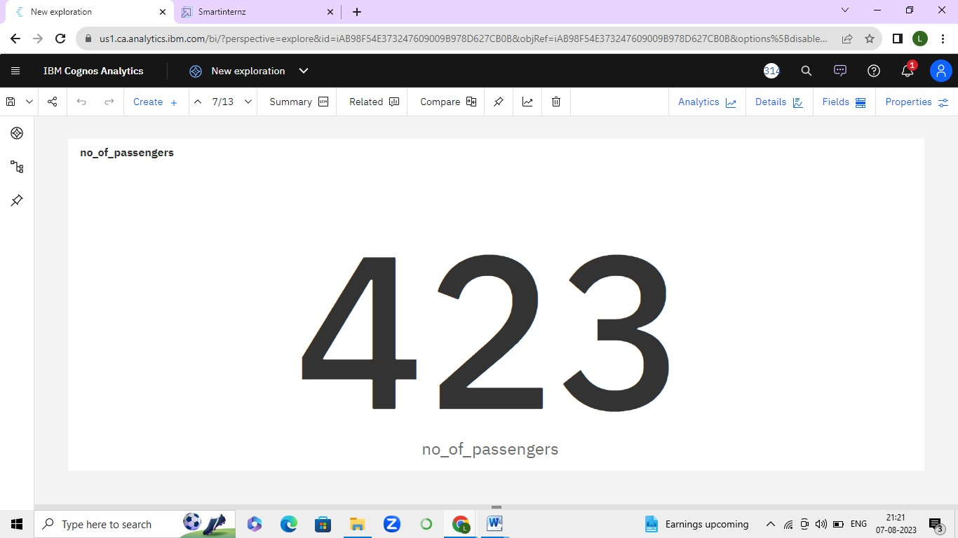

INR_Amount by Day of the week:

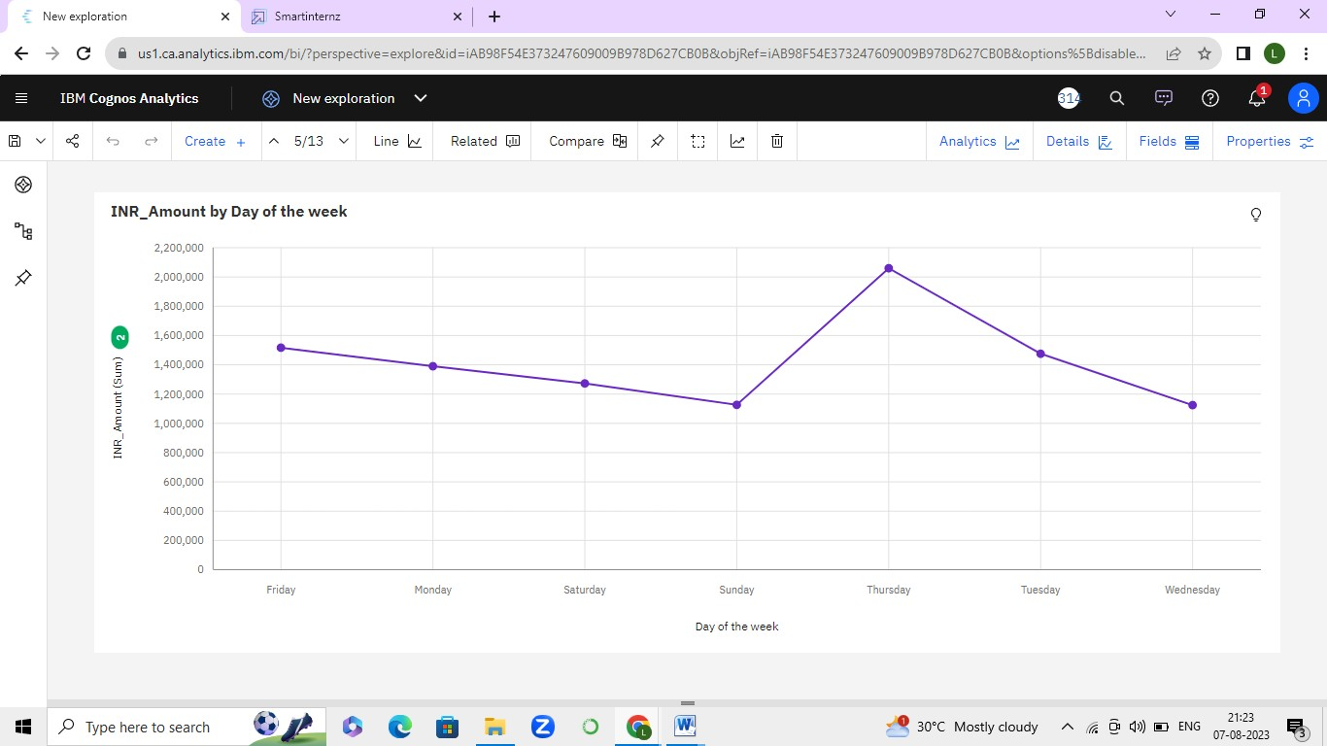

INR_Amount and Day of the week:

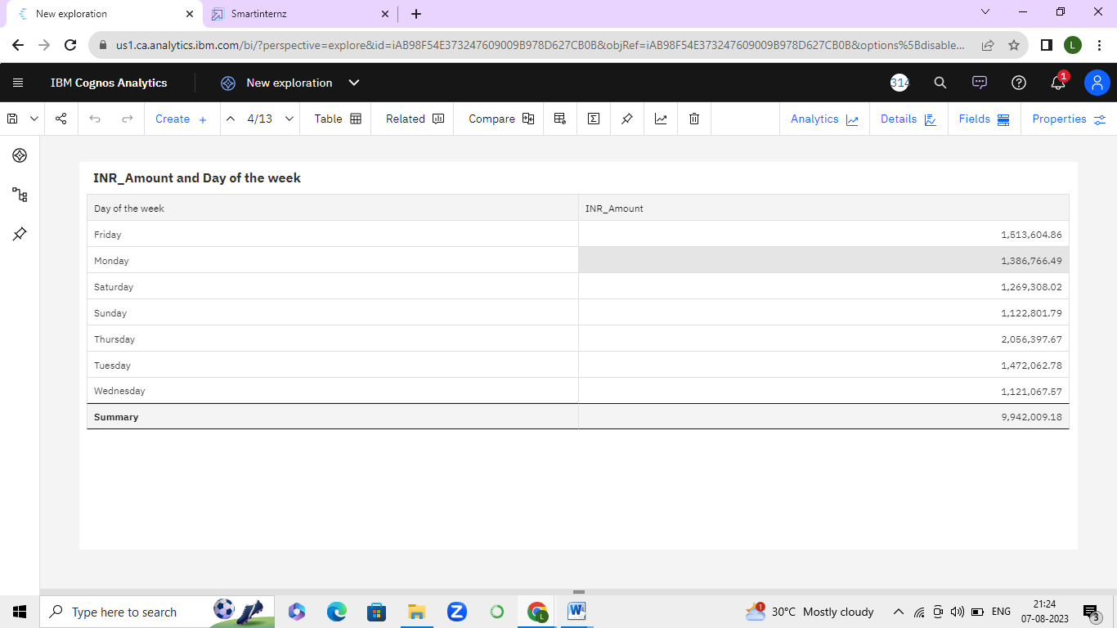

Comparing 2 visualizations:

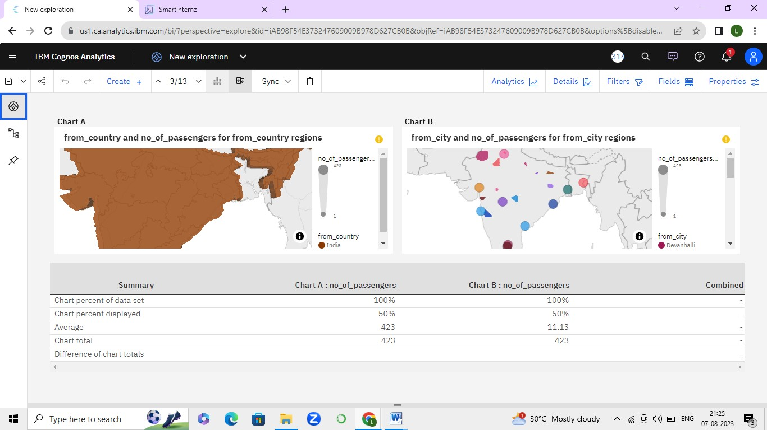

**TRAVEL AGGREGATOR SLIDE STORY:**



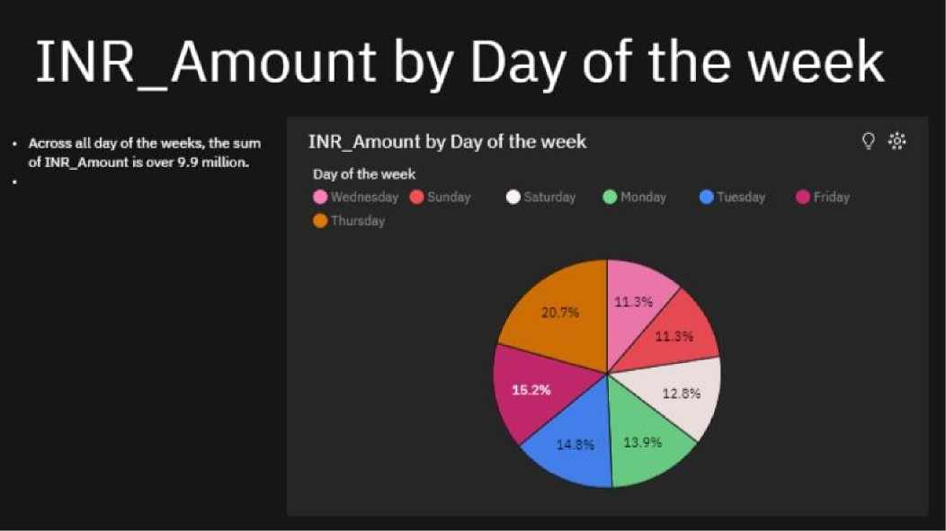



TBMGognosAnaQtcs

travel Aggregators Story

O



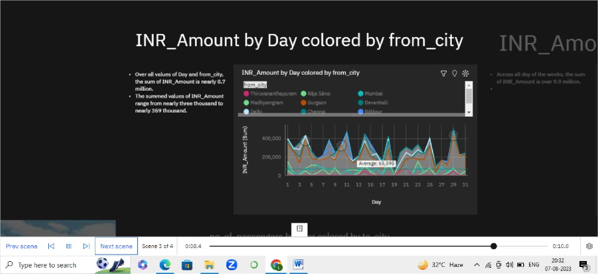

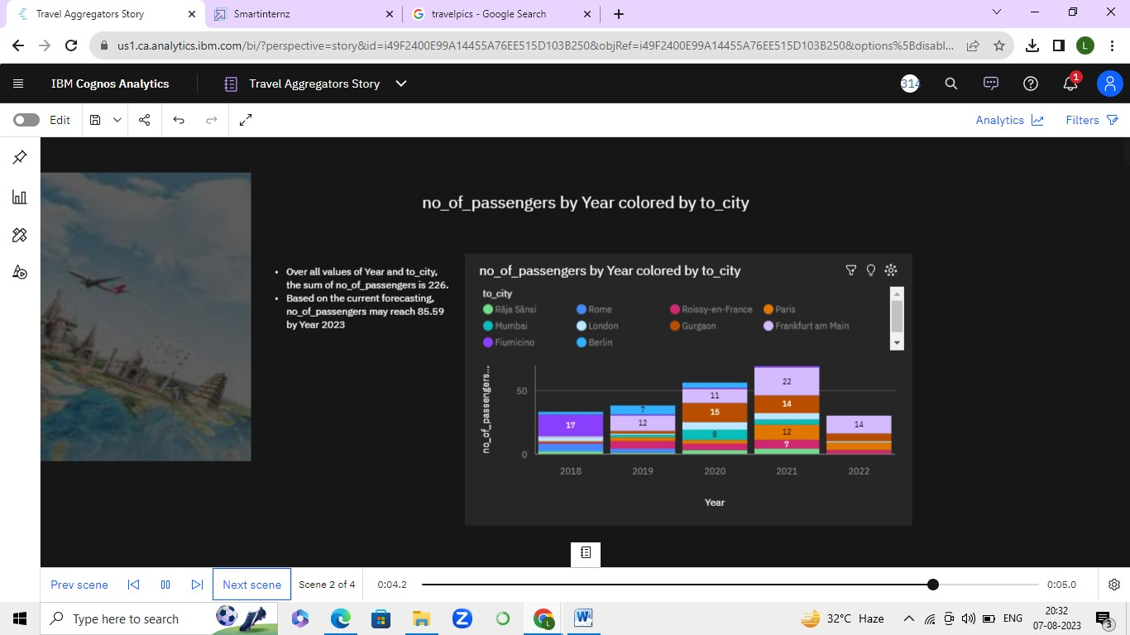

**TRAVEL AGGREGATOR DASHBOARD :-**

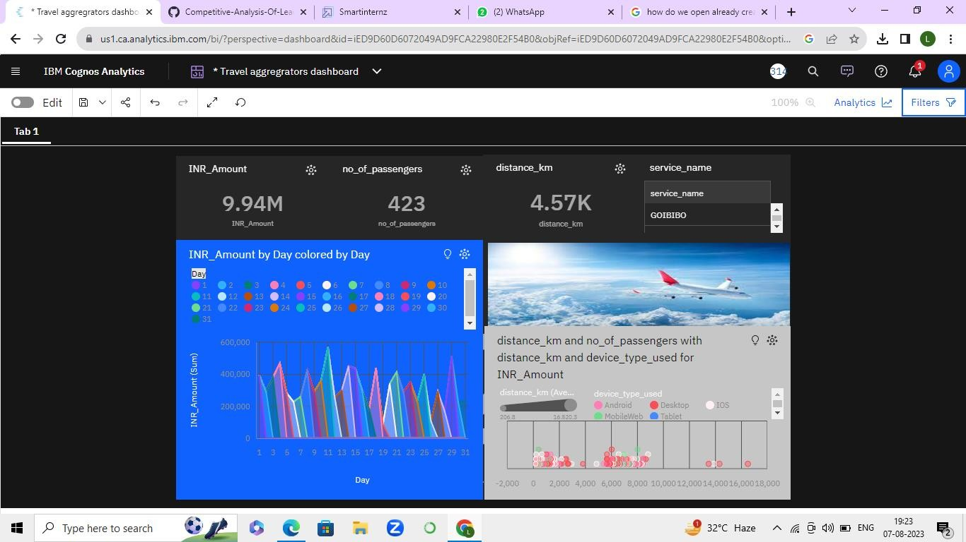

**TRAVEL AGGREGATOR REPORT:**

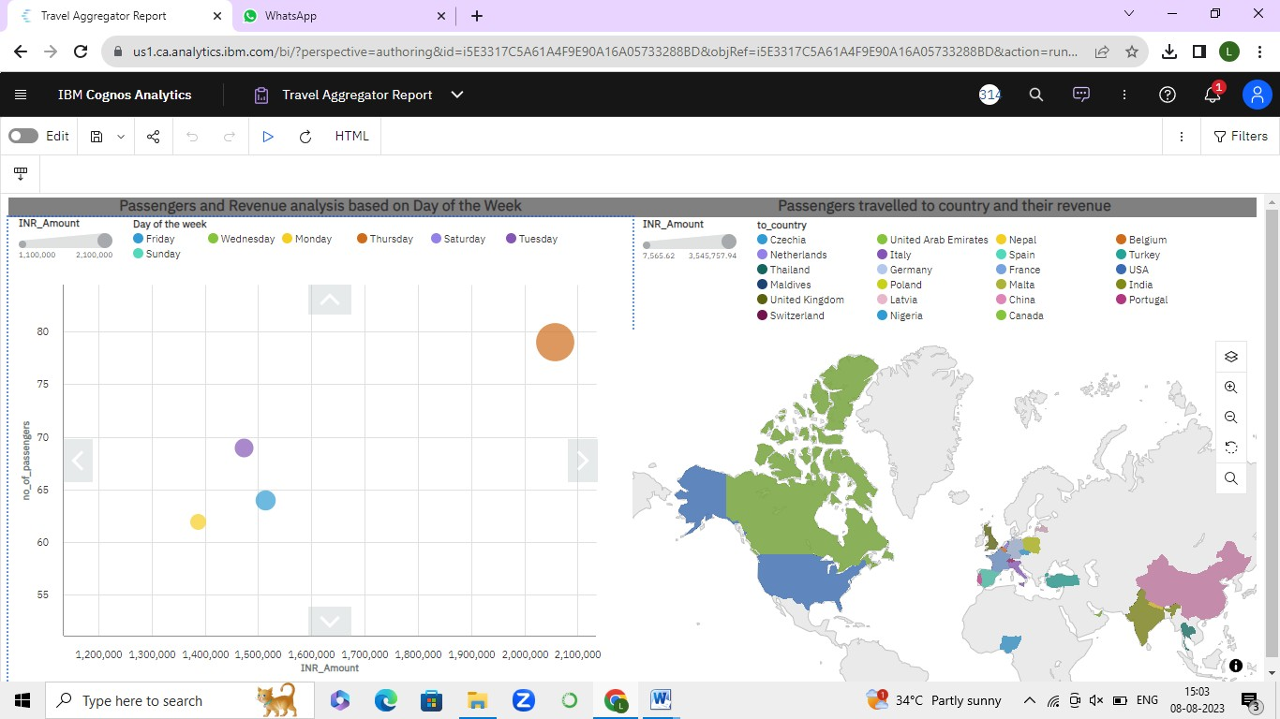

**WEB INTEGRATION:**

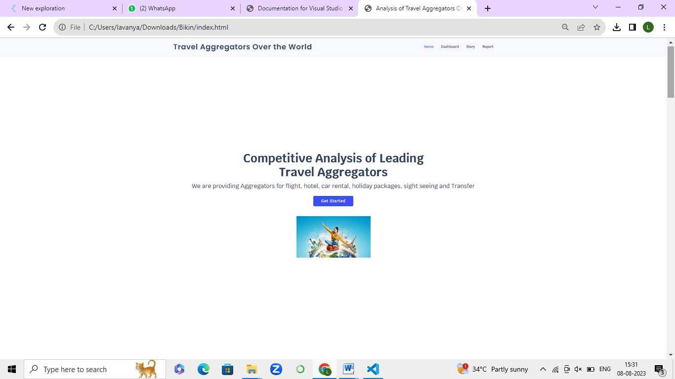





Travel Ag gr egot ors Over the Wo rl d

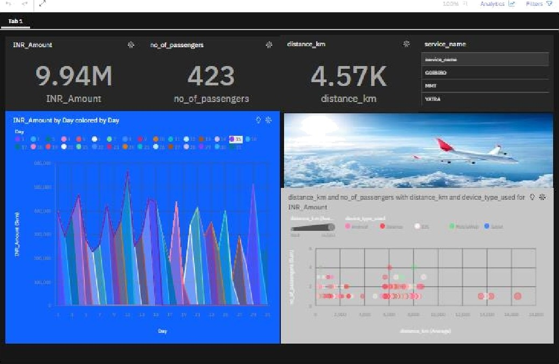



*ffi*

-IIe C:/Users/Iayanya/DownIoads/Blkin/index.htm I

Tra vet Ag gr egot ors Ove r t he wo rl d

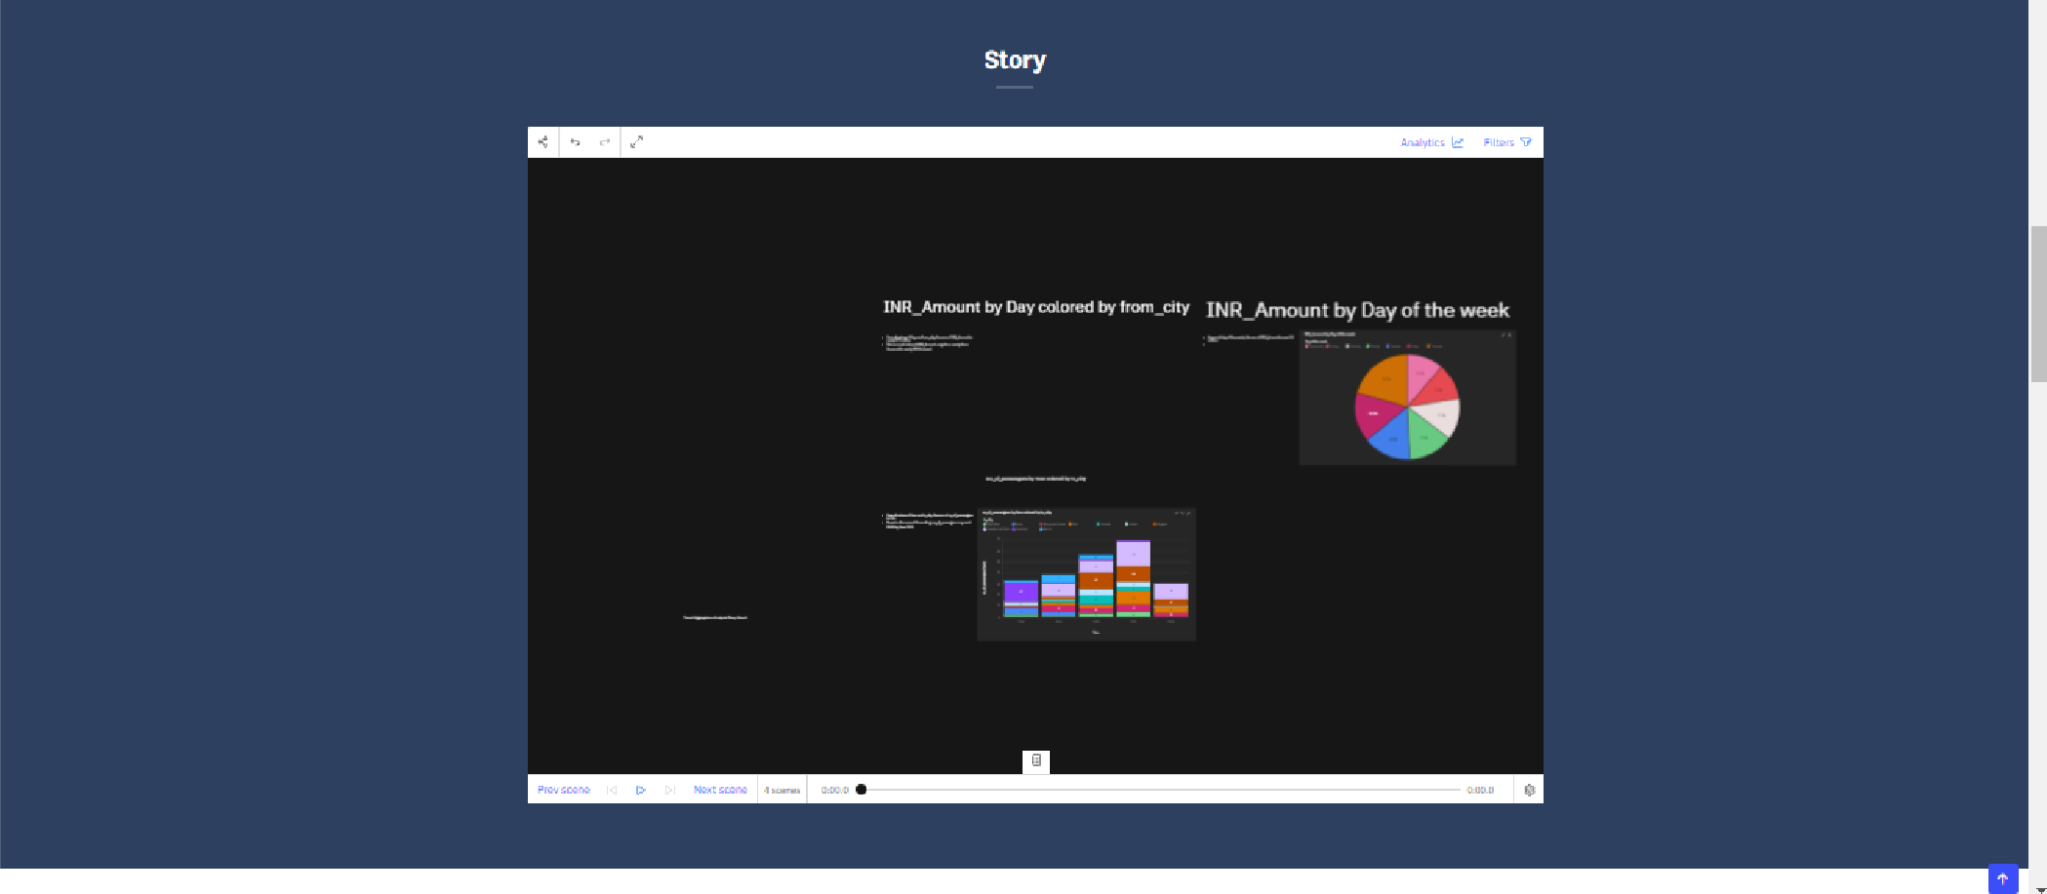

c¿ Q Type here to search

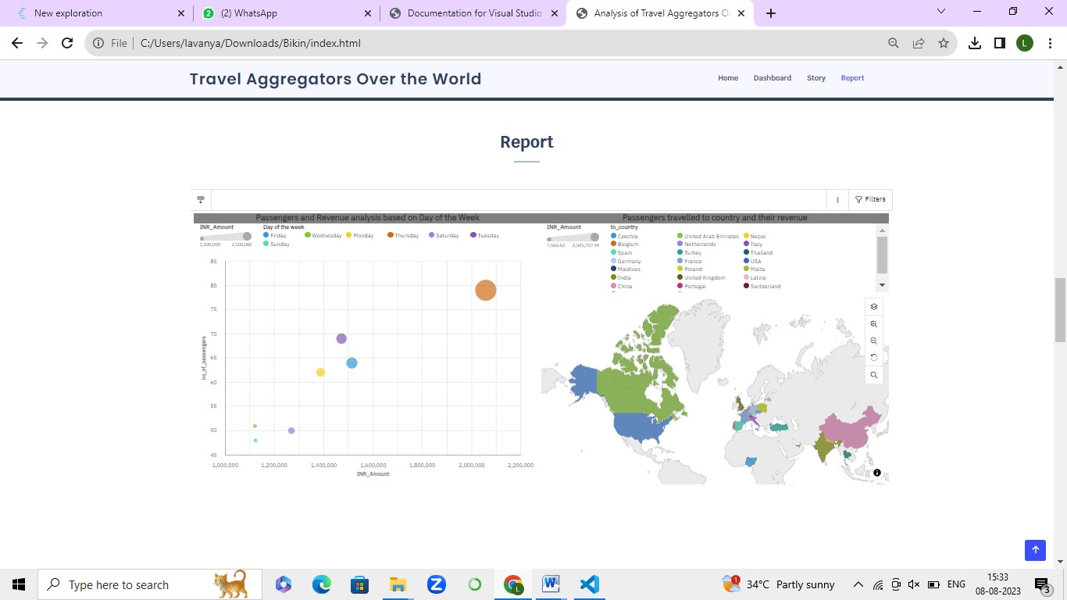

ADVANTAGES:

1.Benchmarking Performance 2.Strategic Decision Making

3.Identify Market Opportunities and Gaps 4.Competitive Pricing Strategies

# DISADVANTAGES

1.Incomplete Information 2.Bias and Subjectivity

3.Time and Resource Intensive 4.Dynamic Market Changes 5.Focus on Short-Term Tactics

# APPLICATIONS:-

The competitive analysis of leading travel aggregators has various practical applications for businesses, investors, and industry stakeholders.

1. Business Strategy Formulation
2. Market Entry and Expansion Planning
3. Product and Service Improvement
4. Pricing and Promotion Strategies
5. Investment Decisions
6. Partnership and Collaboration Opportunities
7. Identifying Niche Markets
8. Risk Assessment and Mitigation
9. Talent Acquisition and HR Strategies
10. Innovation and Technology Adoption
11. Brand Positioning and Differentiation:
12. Monitoring Competitor Moves

# CONCLUSION:-

In conclusion, the competitive analysis of leading travel aggregators provides valuable insights into the dynamic landscape of the online travel aggregation industry. Through a systematic examination of key players, their strategies, strengths, weaknesses, and market positioning, this analysis offers a comprehensive understanding of thecompetitive landscape and market trends.

# FUTURE SCOPE:-

The future scope of competitive analysis of leading travel aggregators is promising, as the travel industry continues to evolve and adapt to changing consumer preferences, technological advancements, and market dynamics.

The future scope of competitive analysis of leading travel aggregators is Characterized by continuous innovation,technological advancements, customer-centric strategies, and a focus on sustainability.

----THE END----